


Improve leadership and culture
of every team. Powering a new
level of HR business partnering.

OUR NUMBERS = OUR OPPORTUNITY

To improve business performance at
Cognizant

Table of Contents
Unleashing Leadership Potential: The REACH Advantage 5
Attract Great People 6
Selection 8
Onboarding Lays The Foundation 10
Teamwork – Productive Collaboration 11
Maximise Contribution 13
Feedback for Performance 15
Staff Development 16
Engagement Our Ultimate Competitive Edge 18
Succession Beat Bias With Data Led Succession Planning 19
Emerging Leader Development 20
How does REACH help? You’re set up for success with 3 tiers of leadership development 21
Leaders Can Purposefully Build Teams To Be Productive 24
Separation 25
REACH LX is a subscription-based software platform. 27

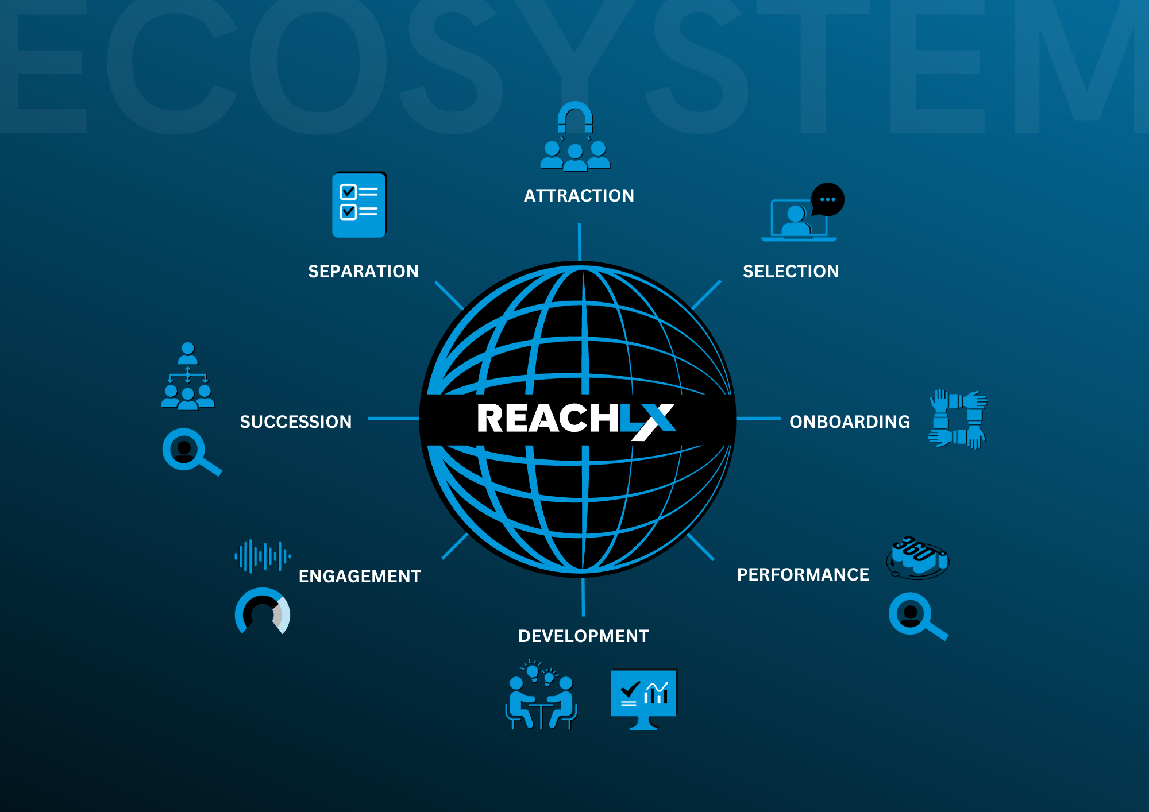

Right now at Cognizant we estimate that we:
Summary of Our Current Numbers.


Have Lost Revenue of: $112,407,704
- We currently estimate that we’re losing $112,407,704 per year because we have 75000 empty seats.
- 0 team members have reduced productivity of 0% and are at risk of burnout.

Losing $-1,107,004,592 p.a. due to mis-hires
- We are currently losing around $-1,107,004,592 from mis-hiring 70000 people per year.
And losing substantially more than $-1,107,004,592 due to regrettable loss
- Last year, we lost people that we identify as regrettable loss. The loss of contribution from great people is almost immeasurable, furthermore, the cost of replacing a person is 2.5X their salary. So the cost has a double amplification of loss of contribution and literal costs of replacement.
  - Lost productivity:
- We lose productivity and good new-hires due to aspects of our onboarding. We currently rate the success of our onboarding at preparing and engaging new team members for their role 0/10 at preparing and engaging new team members for their role.
- People only spend % of their time working to their strengths. Which means we don’t have the first essential ingredient for them to get in-flow and be 500% more productive only 100% of the time.
- We believe that only 0% of our teams have an effective two-way feedback loop which means team performance and leadership performance is diminished in all of those teams.
- We estimate only 0% of our workforce are actively engaged. Furthermore, we estimate that 0% are likely to be actively disengaged and working against us.
Succession planning:
- Improving our succession planning is currently a 1/10 priority for us. This is a longer-term strategic risk.


Unleashing Leadership Potential: The REACH Advantage

Unlock untapped potential and profits with the REACH LX Platform. Seamlessly bridging cutting-edge research with easy-to-use leadership products, that equips leaders to excel.

The products in the platform are grounded in a rich tapestry of insights from luminaries like Dan Pink, Patrick Lencioni, Dr. Carol Dweck coupled with pivotal studies from giants like Google’s Aristotle Project and top-tier research firms such as McKinsey and Gallup.

With REACH, leaders gain access to distilled wisdom, translated into intuitive tools for daily leadership.

The result? Leaders not only elevate their leadership experience (LX) but also drive teams to peak performance.

REACH provides the most comprehensive and evidence-based tools for leaders to be more effective at every stage of the employee lifecycle. Which means you can ensure that no opportunity, money, or productivity edge is ever left on the table.

Attract Great People
  - Reduce the cost of empty seats
Every unfilled position in an organisation is not just an empty seat—it’s missed potential and lost revenue.
  - Here’s how the costs stack up:
We currently estimate that we’re losing $112,407,704 per year because we have 75000 empty seats. Our empty seats are reducing the productivity of 0 people by about 0% and those people are heading for burnout. These people under undesirable stress are at a higher risk of burnout, and resignation – which would lead to additional empty seats and further amplify our challenges.



The Overwork Factor:
Empty seats strain existing teams, leading to burnout, reduced focus and accountability challenges. This is more than a simply loss of productivity, it's morale crushing. Unrealistic or unsustainable expectations/not having adequate resources to do the job is the number 1 reason people resign before even finding another job. Yes, this is the number 1 reason that good people just 'quit'.

  - Revenue Per Employee:
Revenue per employee is a commonly used metric for benchmarking companies. Depending on the industry, each employee represents $200,000 to $4,000,000 in revenue. Calculate your organisation’s revenue per employee by dividing annual revenue by headcount.
The Solution?

  - Fill our empty seats with a compelling attraction strategy including the unique 'Personal Development Dashboard'.

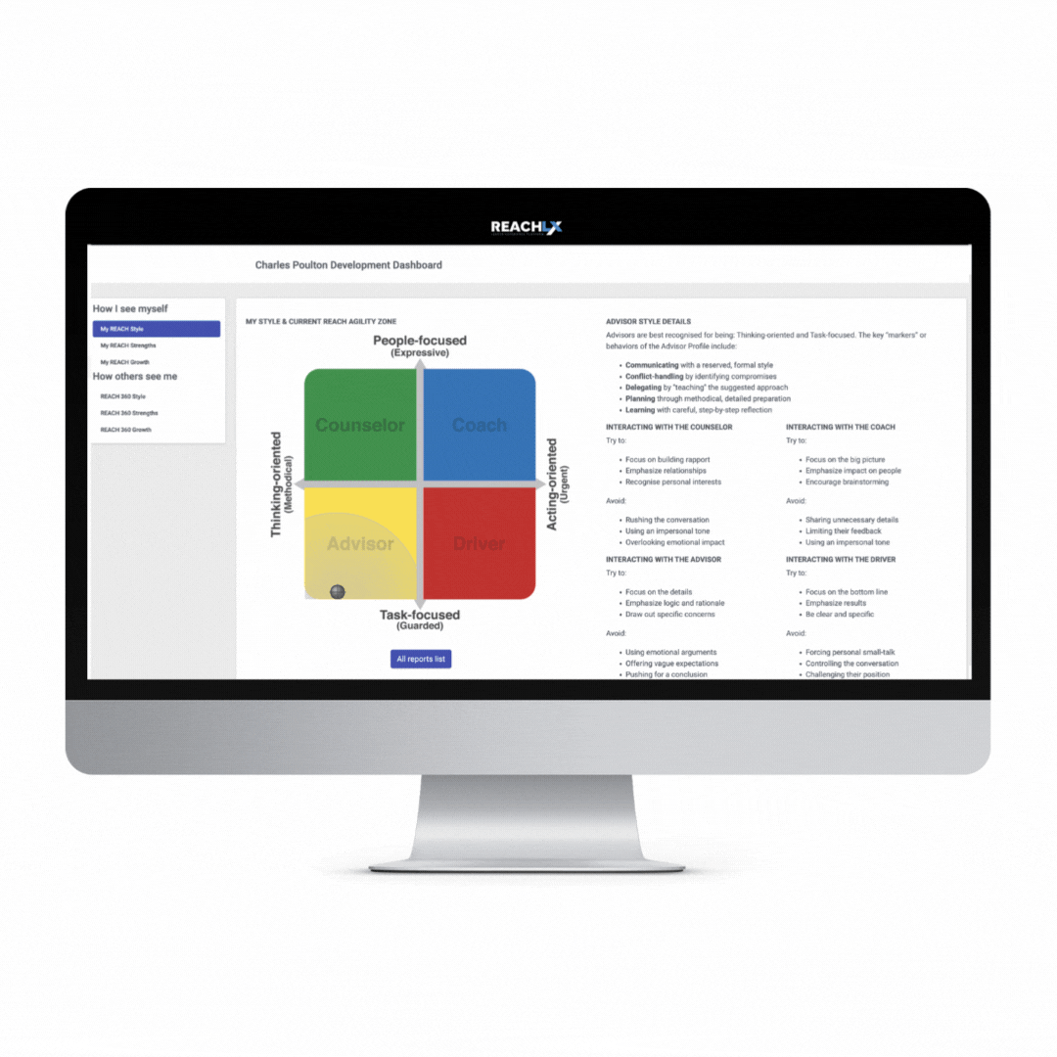
Research indicates around 1 in 3 people that are actively seeking a new role are doing so because they are in search of personal growth opportunities. (McKinsey, Gallup etc)

In just 15 seconds, deliver on the promise of investing in them on day one!

By simply updating an email address, new hires receive a personalised development dashboard on their first day—a mere 15-second task with zero cost.

With REACH you can demonstrate your commitment to their growth as soon as they come aboard.

Demonstrating that our promises are genuine is critical to securing new staff because a Muse study in 2022 reported 72% of people who changed jobs in the Great Resignation in 2021 experienced ‘Switch Shock’ when expectations set during recruitment were not met, causing many to quickly change again.

Which means that candidates are now careful to evaluate employers before jumping onboard.

Selection
The science of avoiding the most common hiring mistake
Mistakes in hiring aren’t just errors - they’re costly setbacks.
  - We’re currently losing around $-1,107,004,592 from mis-hiring 70000 people each year at an average salary of $106,899.
According to Gallup replacing an employee can cost up to 2.5X their annual salary in direct expenses including recruitment, training, onboarding and ramp-up period.
Even worse, when you factor in the ripple effects of team productivity & morale (not to mention the impact on customers), the true cost skyrockets well beyond that figure.

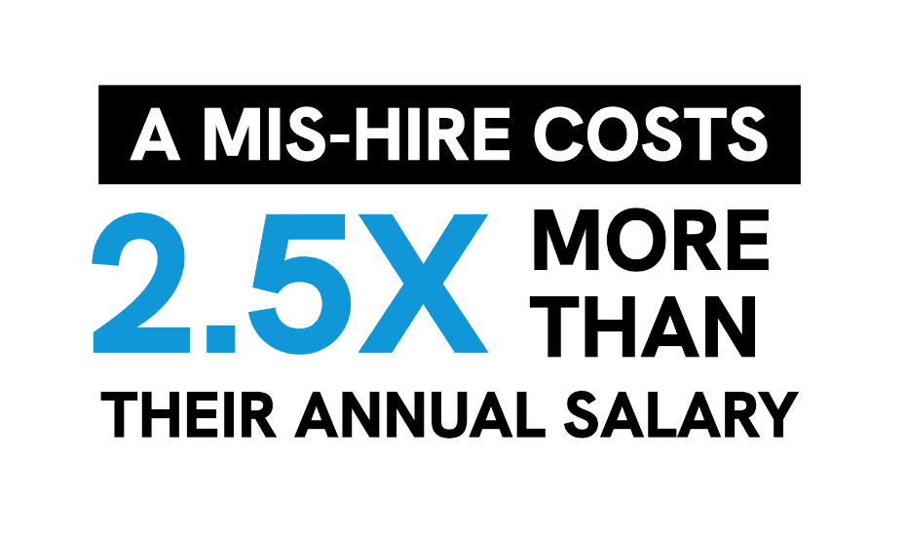
  - The Common Pitfall: Using past job titles as a predictor of success.
Relying primarily on past titles is the most common mistake. A role with the same job title in different organisations can be very different, call on different strengths, and suit different personality styles. For example, a role with the same job title in a scrappy fast-moving startup, cautious slow moving government, or policy-driven multinational can demand vastly different strengths.

Equally, a role with the same title, can be very different in one multi-national to the next, and from one start-up to the next. In short, selecting a person because they have filled a role with the same job title, while important, isn't a great predictor of success in your organisation.

The Solution: Strengths-Based Interviewing using the unique 'Final Interview Companion'.

It’s critical to ensure alignment between the candidate’s strengths and the unique demands of your version of the role. The unique Final Interview Companion equips leaders with a data-driven, effective strengths-based interview tool.

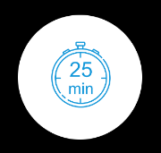
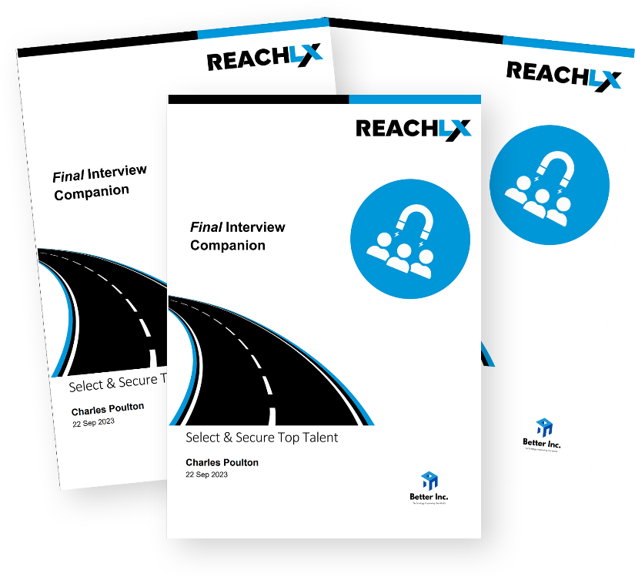
Just 25 minutes and $0 can drastically reduce the risk of a mis-hire.
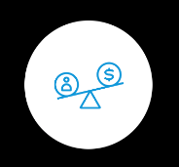
Compared to the staggering costs of replacing an ill-fit employee, it’s a no-brainer.

Secure the best fit for your team and culture more often.
Equip your leaders to make better hiring decisions and avoid expensive hiring mistakes.

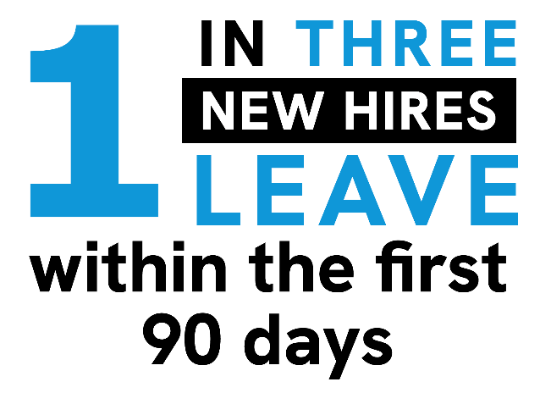

Onboarding Lays The Foundation
Avoid Losing Great People In The First 90-days
  - We estimate that people are only 0/10 engaged and prepared for their role at the end of induction. This requires attention, because a negative onboarding experience reduces productivity and leads to employees being 2X more likely to look out for other jobs, leading to loss of high-potential people.

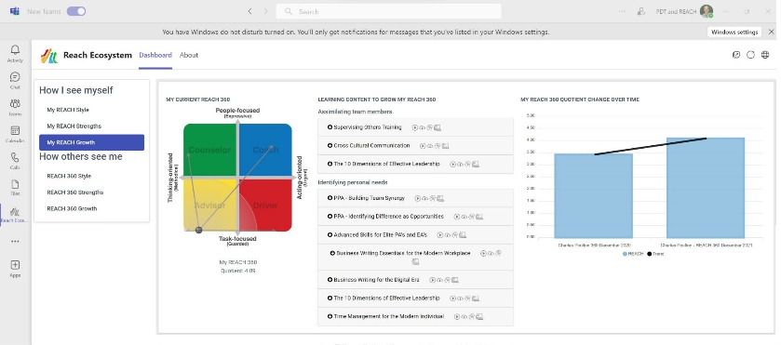
  - Onboarding isn’t just a process - it’s a pivotal moment that can make or break an employee’s tenure. Equip your leaders with these two effective onboarding tools, proven to dramatically improve retention and engagement:
  - Automated Personal Development Dashboards:
2021 Gallup research indicates when clear development plans are included in onboarding, new hires are 3.5x more likely to rate their experience as exceptional.

With REACH, leaders are able to meet this need via the unique Personal Development Dashboard, for each new-hire. It’s automated, instant and there’s no additional cost.


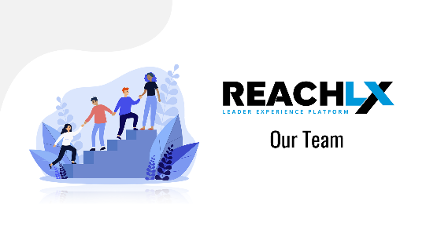
  - Team Integration:
Employees introduced to their teams and aligned with company goals during onboarding are 2.6X more likely to believe they’re in their ideal job. (Gallup 2021). Again, leaders are provided with a unique, no-cost, easy to use product called the Team Formation Companion ensures new employees experience helps them feel connected with and understood by their new team. So their initial day-1 enthusiasm is maintained or amplified as they feel invested in, and connected with their team.


Teamwork – Productive Collaboration
  - Get More Done - Move Teams From 'Storming' To 'Performing'
  - We estimate that 0 teams are under-performing due to personality clashes or counter-productive conflict.

The Challenge: Conflict Caused By Personality Clashes Kills Productivity
As teams evolve, especially during growth or change, they often grapple with phases of 'Forming' and 'Storming' — periods marked by counter-productive conflict, reduced productivity, and waning morale.
Think about the mental energy and focus that gets consumed by counter-productive conflict. How much time people spend gossiping, resenting, sometimes even plotting and undermining. Think about those times when there's tension in the air, and people are waiting to see what happens next, or 'tread on eggshells' to avoid further inflaming the situation.
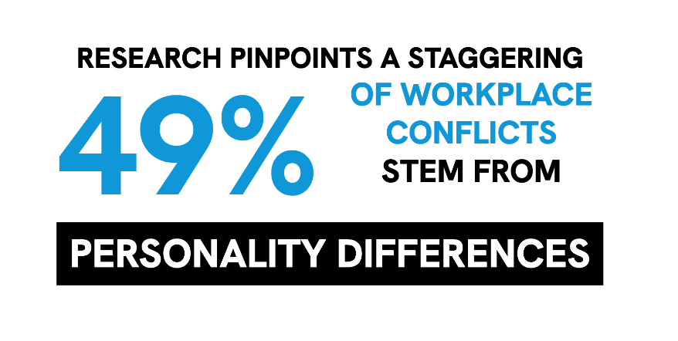
Now think just how far away from goal-oriented, constructive collaboration and client-focus that is - everything that doesn't demand immediate attention falls by the wayside. The team grinds to a halt.
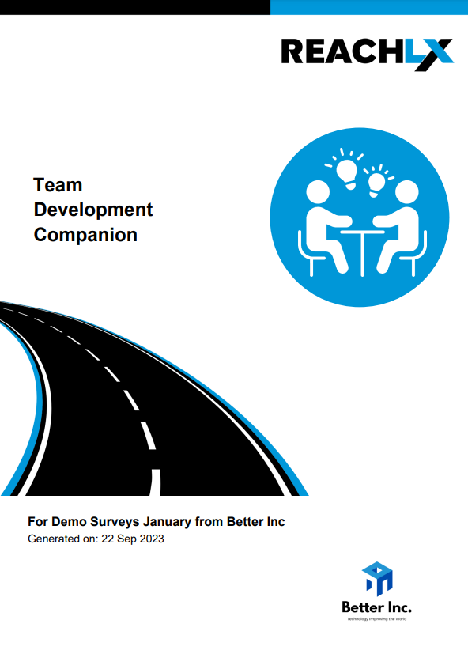
Without insights AND easy-to-use resources, leaders can find themselves at a loss to steer the team back to 'Performing'. Which means team productivity can stall for weeks, months or even years.

The Core Issue: Personality Clashes
To swiftly navigate from 'Forming' and 'Storming' to 'Performing', teams need trust, mutual understanding, and an appreciation for diversity.

The Solution:
The REACH platform uniquely delivers tailored reports, presentations, and insights based on each leader's team dynamics, composition, and current phase.

Leaders are equipped with different tools for different moments in time.
For example, new teams often stall in 'storming' because it takes a long time for people to understand each other through day-to-day interactions.

So leaders tend to use the 'Formation Companion' with new or changing teams. While leaders of existing teams often utilise the Team Development Companion. These unique, powerful and simple to use tools empower leaders to swiftly steer teams back to peak performance.

  - Key Insight:
  - 49% of team conflicts arise from personality clashes. If your leaders aren't equipped with easy to implement, always available tools to take action, the problems can fester for weeks, months or even years. Are your leaders equipped?

Maximise Contribution
  - Improve Productivity by up to 500%
People contribute to their full potential, make fewer errors and are more proactive when working to their strengths, currently, we estimate that our people probably only spend % of their time working to their strengths.

When individuals operate from their strengths, they’re not just more engaged - they’re exponentially more productive.

The magic happens in the 'flow-state,' where research reveals a staggering 500% boost in productivity.
(Behavioural Sciences longitudinal study)

The work needs to be the right level of difficulty, and other conditions need to be conducive - e.g. people need the right resources, and negative conflict can't be consuming the energy, however to get engaged in their tasks people need to be 'playing to their strengths'.

  - What does it feel like when your team isn't working in their strengths?
When people are working in their weaknesses, they feel flat, they get the job 'done' and not much more - because they are doing the job out if a sense of duty, but they don't enjoy the task. Which means they have less attention to detail, more errors, less creativity and virtually no proactivity. This means as a leader you have a team you need to 'manage and monitor', performance is never the standard you hope for, and the team is never energised or enthusiastic.
What are your experiencing most of? An energised, productive, high-performing team? Or a team of people 'doing what's required'?
To create the opportunity for 500% increased productivity, leaders need access to these unique strengths-based management tools:

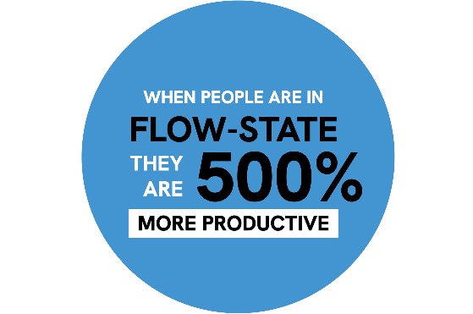
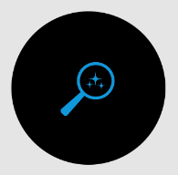
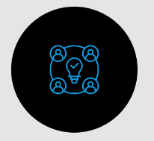
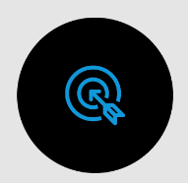
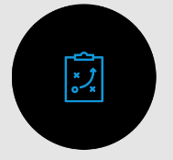
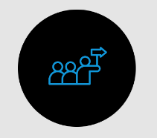
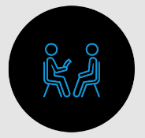
Feedback for Performance
  - The Impact: People
get in flow-state more often.
While it's unrealistic to expect constant flow-state or perpetual strengths-based work, imagine the transformative power of just a 20% increase.

That’s akin to supercharging productivity by 500% for an entire day each week!
  - Strengths-Based Leadership:
Strengths-Search Module
If you’re delegating, promoting or assembling project teams, this module provides instant insights so leaders can craft the perfect project teams.
  - Team Strengths Discovery Workshop:
A quick (60 minute) yet effective workshop to help the team achieve greater productivity by learning about each others strengths and work preferences.

  - Personal Strengths Discovery
Each person discovers their personal strengths and they are top of mind by inclusion into Personal Dashboards.
  - Playing to strengths Survey:
Use the unique 3-minute survey to understand how much of your workforce is contributing to their full potential by playing to their strengths.
  - Strengths Optimiser Analytics:
Instantly uncover opportunities to improve performance and optimise for strengths.
  - Strengths-Based Interviewing:
Interview Companion
Begin with success. This data-driven tool ensures you’re hiring individuals that will be working to their strengths from the outset.

Individual & Leaders - The Power of Feedback
Feedback improves employee performance and leadership performance alike.
Currently only about 0% of our teams have an effective two-way feedback loop. This needs urgent attention because of the key statistics:

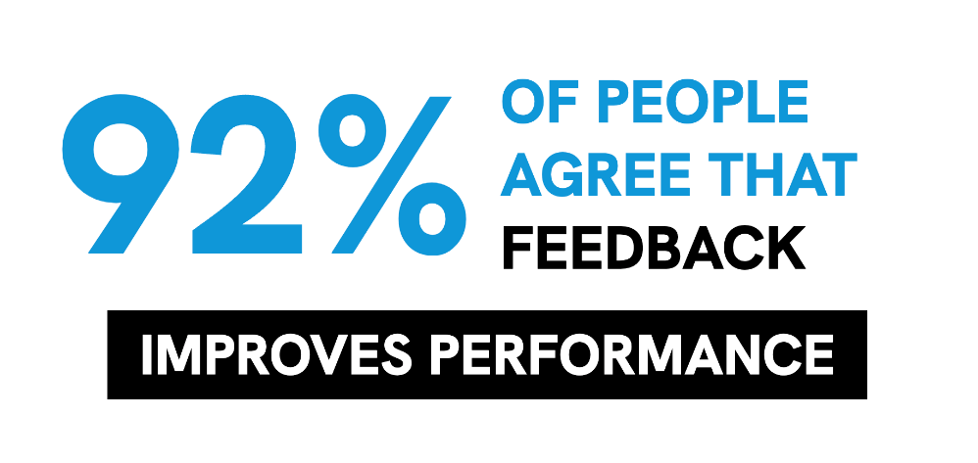
Lack Of Feedback:
40% of employees become Actively Disengaged without regular feedback (OfficeVibe). Think about that, nearly half of your team will actively work against your leaders if they don’t receive regular feedback.

Positive Feedback:
78% of employees feel more motivated when recognised for their work. (OfficeVibe)

Constructive Critique:
92% believe that appropriately delivered negative feedback can enhance performance. (Harvard Business Review)

Consider this: While 52% of departing employees would’ve stayed if the leader made changes, a staggering 66% never shared their needs with their leader. Leaders, armed with the right insights, can prevent such silent exits (Gallup), the only way to gain those insights is through timely and effective feedback loops. Feedback isn’t just information —it’s a powerful gift.

Engaged team members, committed for the long haul, are a leader’s asset. Yet, without data-driven insights, sustaining such engagement is a tall order.

REACH equips leaders with many timely and effective feedback loops such as: 360 tools, Pulse Surveys, coaching relationships and more.

Staff Development
Retain Great People: Using REACH’s Unique Development Tools
Employee development is an effective way to improve performance, engagement and retention, yet at the moment we only rank our development solutions a 0 out of 10.

The Power of Continuous Development:
Employee growth isn’t just beneficial—it’s crucial. It boosts performance, engagement, and retention.

Key Insights
Traditional Challenges
- High costs.
- Competing immediate demands.
- Intangible benefits.
- Lack of resources for leaders.
- Low engagement in HR platforms.

- 68% view training opportunities as a top organisational policy.
- Firms investing in training see a 24% profit surge.
- 87% of millennials prioritise workplace learning.
- Strong training programs boost retention by 30-50%.
- Yet, the top barrier? Lack of time. (LinkedIn 2018)

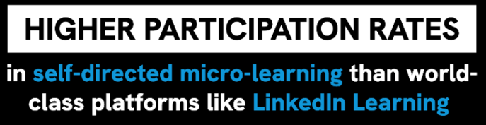
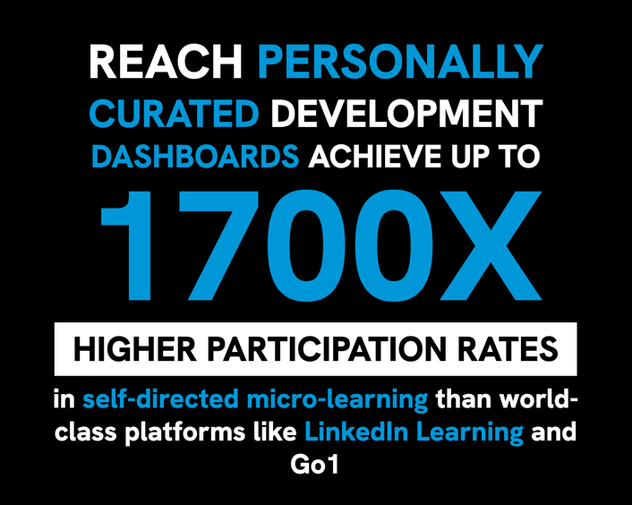
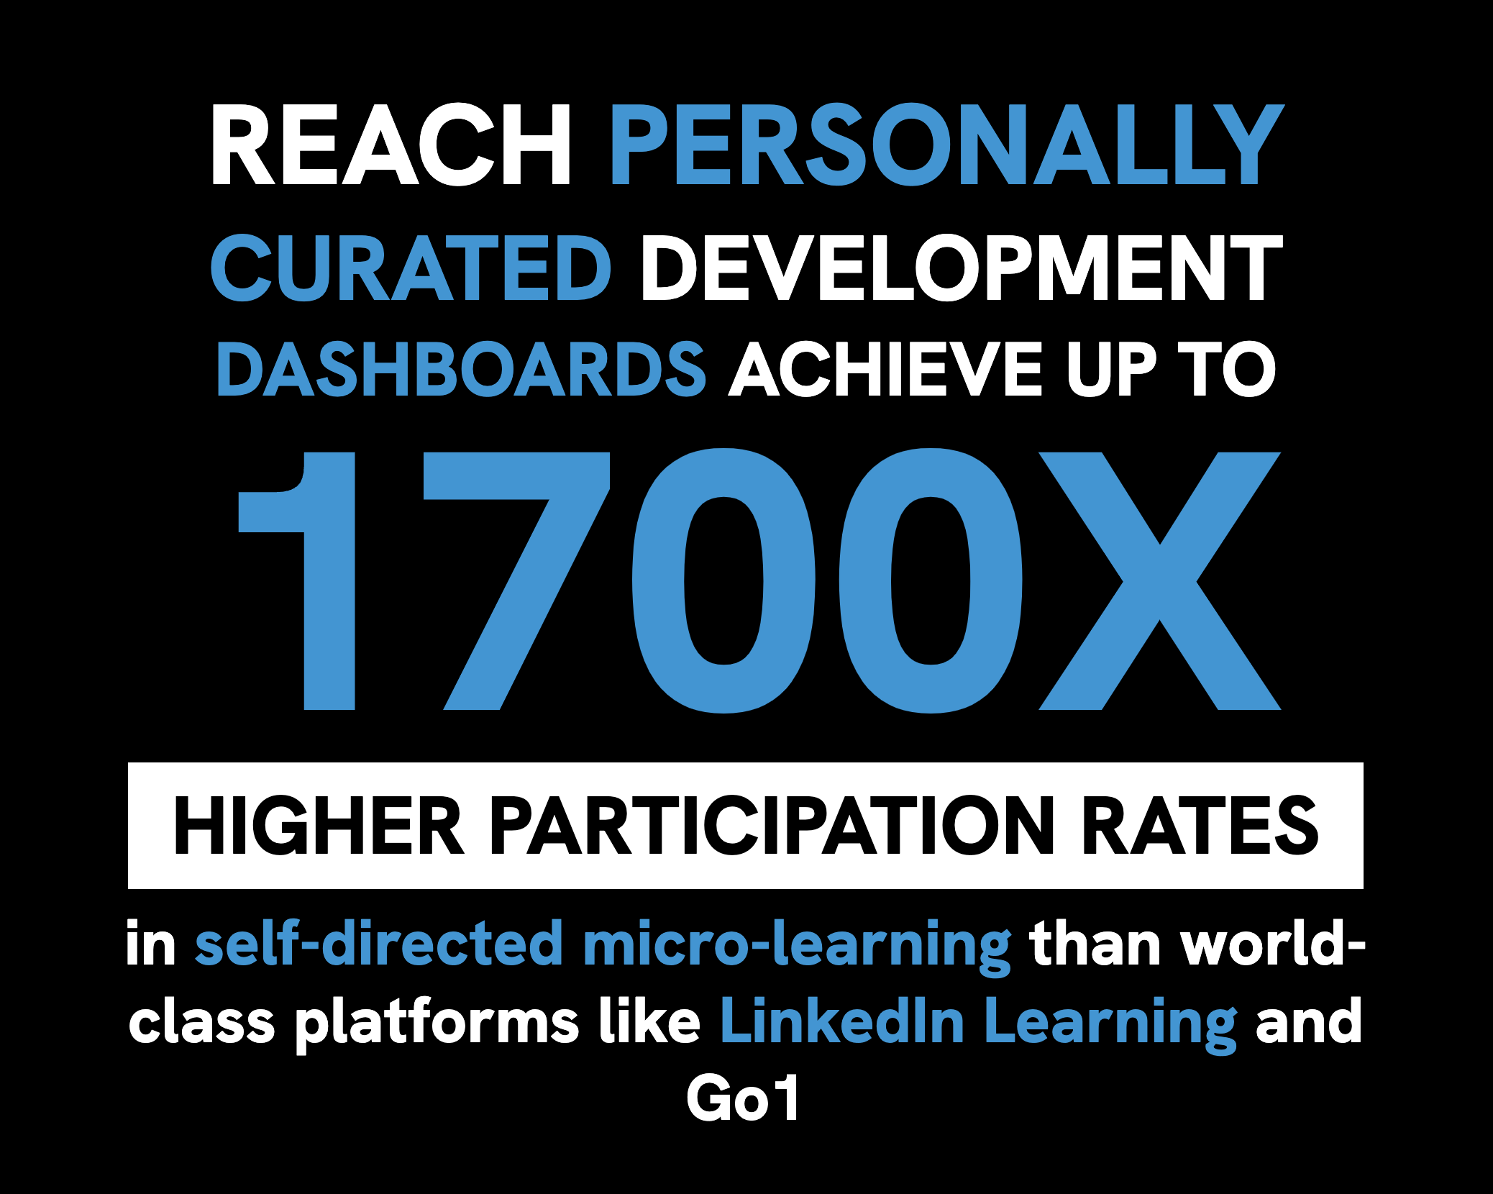
REACH provides leaders with unique tools to overcome the traditional challenges so people can learn in the flow of work:

Dive Into The Future Of Workplace Development With REACH.
Elevate, Engage, And Empower.

REACH Provides 4 High-Impact Curated Ways To Learn In The Flow-Of-Work.
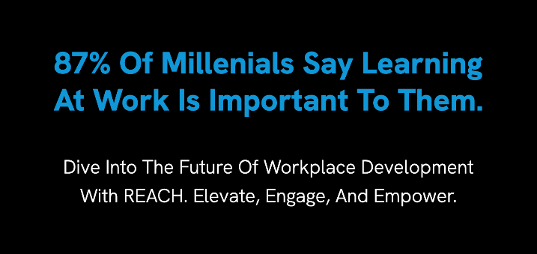
- Personalised Learning: A dashboard curated for each individual, offering bite-sized lessons (~20 minutes per topic) split into 3–5-minute chunks.
- Collaborative Learning: 10-minute targeted activities for team meetings, fostering shared growth.
- Efficient Coaching: Streamlined, best-practice coaching that remains focused.
- Quick Tips – always available and curated for each person.
With outstanding results
- Unprecedented Engagement: Achieving a staggering 1700X more engagement than platforms like LinkedIn Learning.
- Seamless Integration: Directly into tools like Microsoft Teams, eliminating the need for new platforms.
- Measurable Impact: Finally, track real outcomes from Learning, Development, and Culture initiatives.

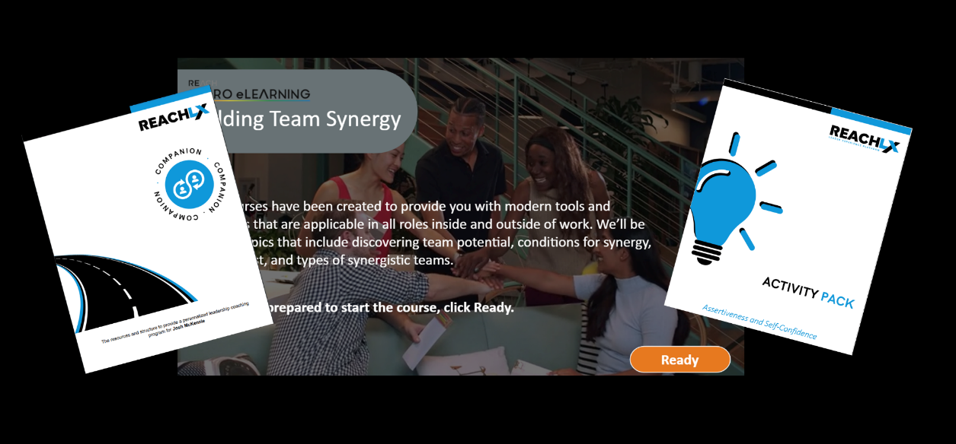
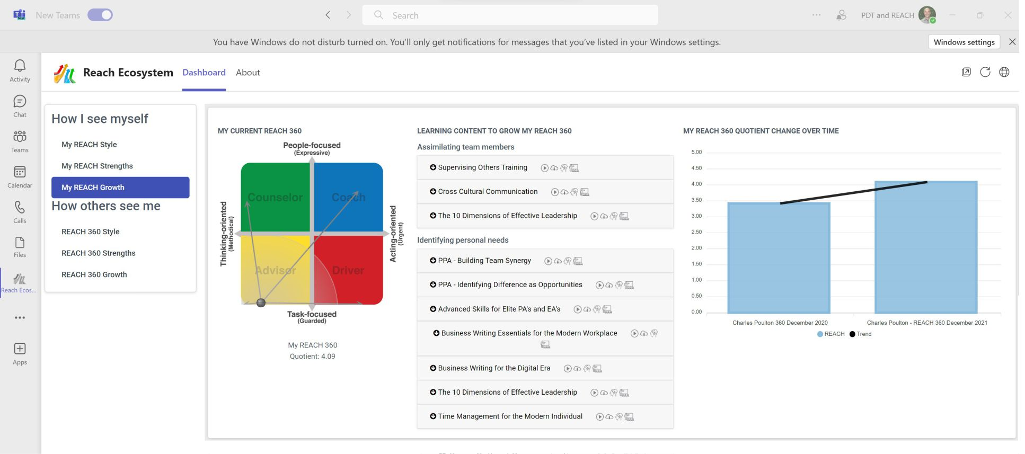

Engagement
Our Ultimate Competitive Edge
Employee engagement is directly linked to performance, profit, proactivity and retaining top talent, yet currently, we estimate our engagement rates are only around: 0%. Furthermore, we estimate that 0% are likely to be actively disengaged and working against us.
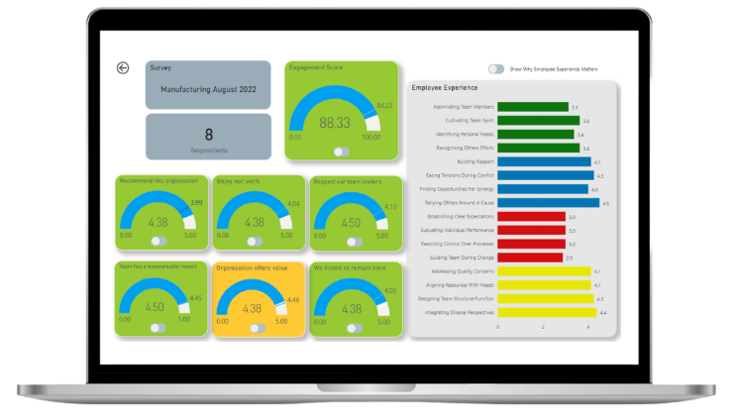
  - Understanding Engagement:
Employee engagement isn’t just a buzzword—it’s the pulse of your organization. It’s the degree to which employees are invested in their roles and the company’s mission. Here’s a breakdown:

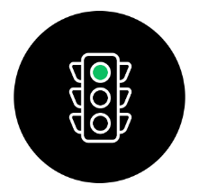
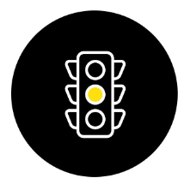
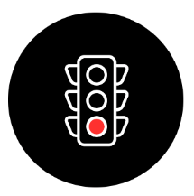
Actively Disengaged
These are your
red flags.
They:

- Sabotage plans.

- Create a toxic culture.
Actively
Engaged
These are your champions. They’re passionate, productive and drive:

- 20% higher profitability

- High employee retention and reduced absenteeism
Passively Engaged
These people are going through the motions and you see:

- Lower productivity

- Lower retention and higher absenteeism
  - Engagement is the difference between a driven, dedicated team and one marred by absenteeism and half-hearted efforts.
In short, engagement is pivotal. It impacts organisational performance, and the daily experience of each leader.
While the team’s leader is the linchpin for engagement, you can’t expect them all to be versed in its intricacies.

Enter REACH. It arms leaders with intuitive, straightforward tools, demystifying team culture. With swift surveys and actionable insights, REACH provides an intuitive traffic-lit dashboard, so they know where to focus, and then instant drill-down to tell them why their scores matter – and tips to improve them.

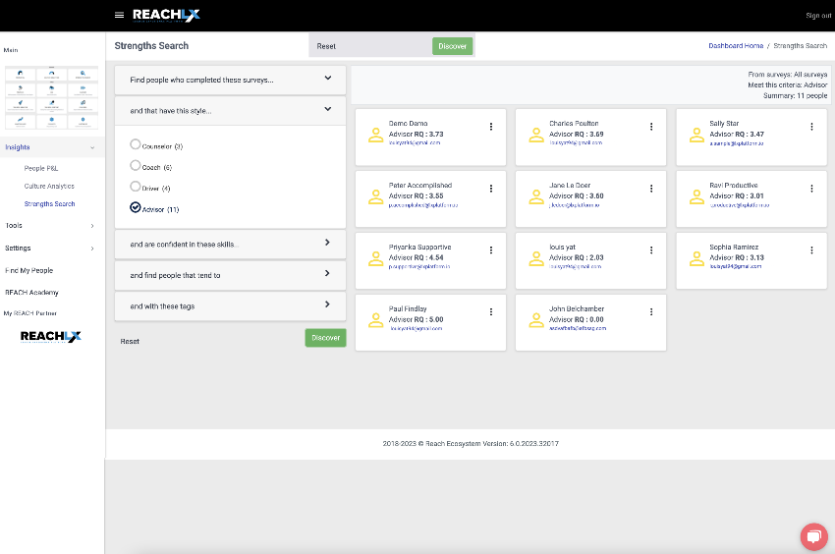
Succession
Beat Bias With Data Led Succession Planning
Succession planning is currently a 1/10 priority for us.

The Problem: According to a report by ATD, only 35 percent of organisations have a formalised succession planning process. What’s more, research from Deloitte shows just 14 percent of leaders believe they do it well.

With the REACH Strengths Search module, you’ll turn guesswork into precision, going beyond the bias of people that you have noticed, and pinpointing future leaders based on vital attributes for tomorrow’s challenges.

By growing the REACH score of your future leaders using the vast resources of the platform, you’ll prepare and then equip your emerging leaders for success as they rise when called upon. Make succession planning your organisation’s data-driven edge.
With REACH, the Strengths Search module provides you with a powerful, data-led approach to identifying future leaders.
...and the rest of the platform provides you everything you need to develop them, and then equip them for success.


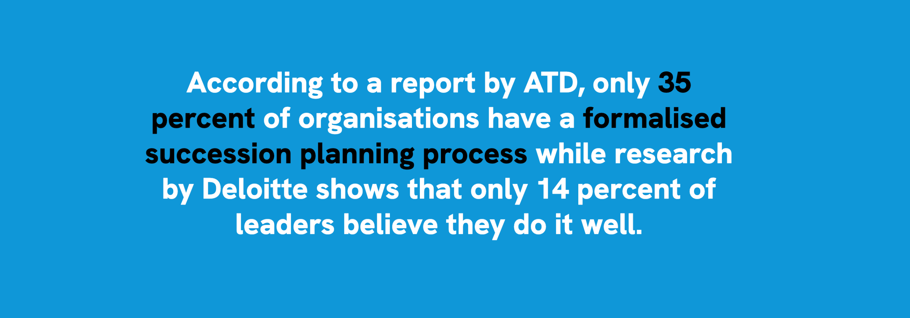

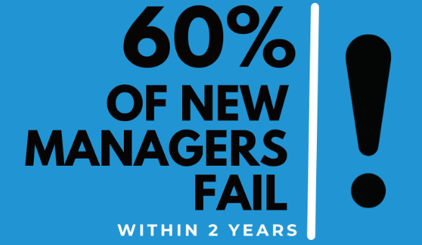
Emerging Leader Development
Develop Leadership Mindset, Adaptability and Skills
Financial outcomes correlate with what we intuitively know.
Surveys indicate that:
- 83% of organizations believe that leadership development should be at every level of the organisation (Harvard Publishing)
- 75% of organizations believe that leadership development should be a continuous process.

And the DDI Global Leadership Forecast 2023 (the largest leadership study in the world with 1,827 human resource professionals, and 13,695 leaders from 1,556 organizations around the world highlights the following key points about leadership and leadership development in 2023/24.
- Organisations with leadership development across levels of the organisation are 2.7X more likely to be in the top 10% financial performers in their industry.
Research shows why development at all levels that prepares leaders early pays such strong financial dividends:
Because without adequate development, 60% of new managers fail (dramatically fall short of expectations or exit) within the first 24 months in their new role, according to research from CEB Global. That’s a staggering number, and the consequences of those failures reverberate throughout the organisation, often with a long-lasting impact.
Managers have an outsized influence on their team members while being key players in nurturing the organization’s culture. When a transitioning leader is struggling, their direct reports perform 15% worse on average than those who report to a high-performing manager. They’re also 20% likelier to leave the organization or be disengaged, according to the Gartner.

Leader-led coaching works (if it’s good quality)
The DDI study also found that while most managers are un-prepared and under-resourced to provide good quality coaching to their emerging leaders.
- However, leaders who get quality coaching from their managers are:
  - 4.3X more likely to feel they have a clear development path as a leader.
  - 2.7X more likely to feel accountable for being an effective leader.
  - 1.5X less likely to feel they have to change companies to advance

Leadership Development is critical to performance and stability – yet we only rate our Leadership Development 0/10 and our leadership development at all levels of the organisation a 0/10.

How does REACH help?
You’re set up for success with 3
tiers of leadership development
1
2
3

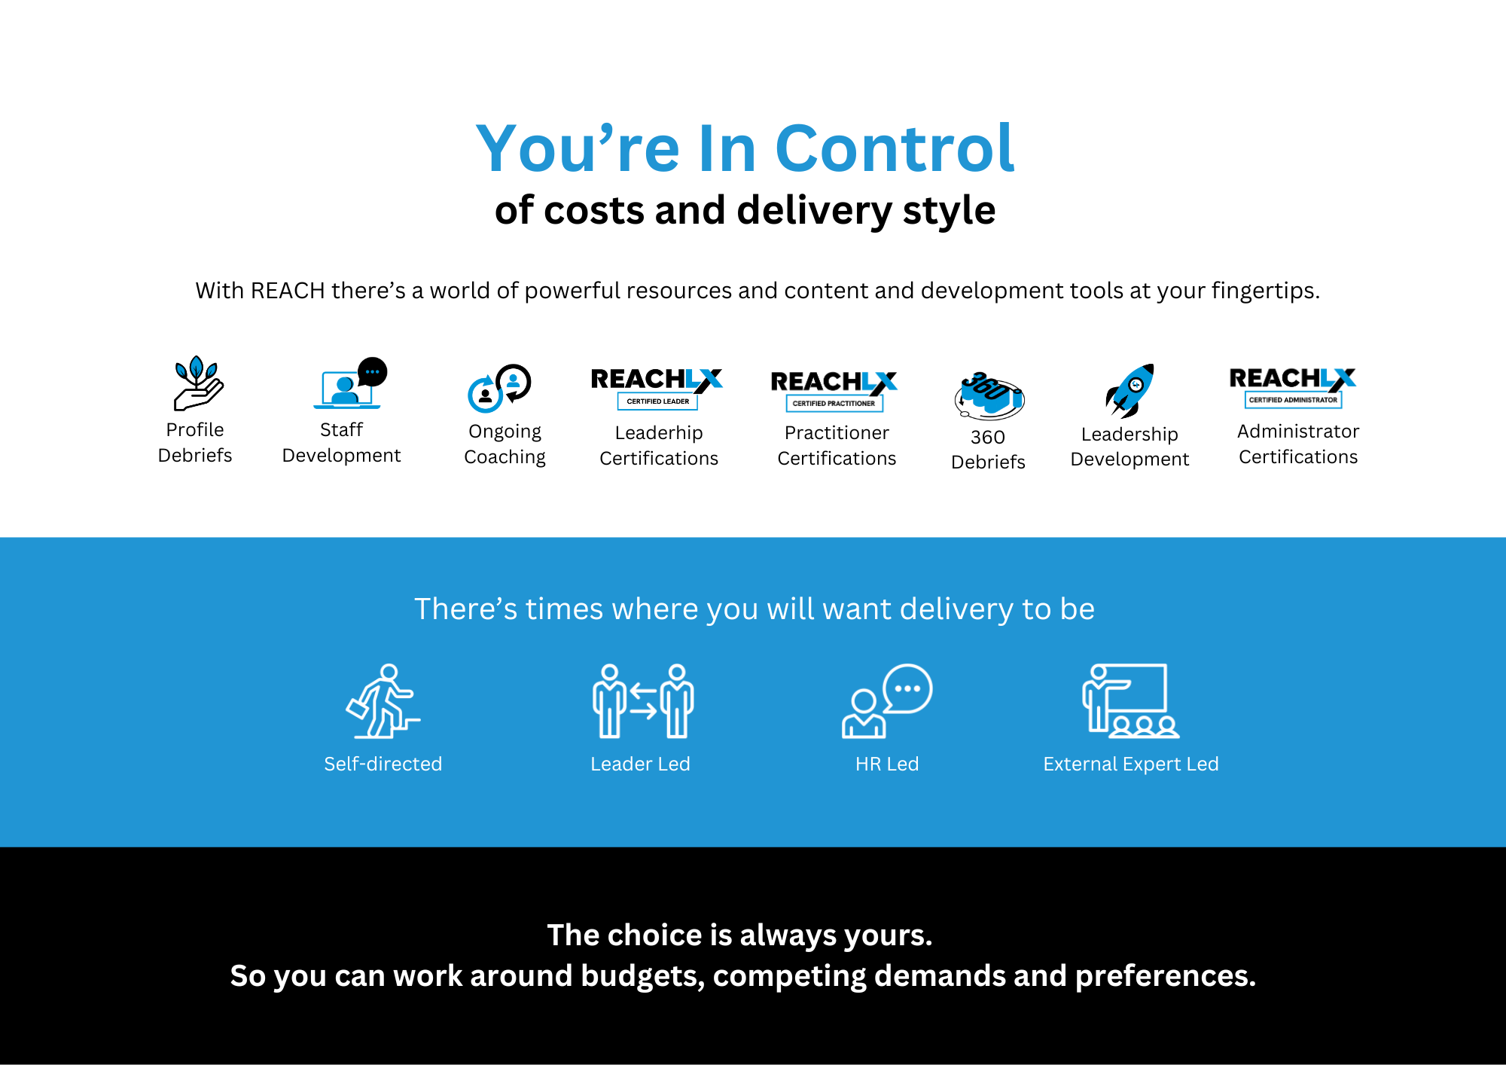
Current Leaders
Emerging Leaders
Leadership Development
At All Levels
- The growth that comes from coaching and supporting growth of emerging leaders
- Leader-led coaching from their management (once again, tailored, structured and removing cognitive load from their manager
- Higher-level workshop resources (5 days of content)
- Customised 360’s targeting their leadership stage
- Leader-led Coaching that works – with automation reducing the load on the coach-leaders.
- Leader mindset/impact on others
- 360 feedback and development
- Developing the experience to see feedback as a gift and to seek it to accelerate their growth
- Full workshop resources (7 days of content)
- Time efficient, mostly self-directed and mostly no cost
- Exceptional engagement and participation rates (up to 1700X higher than leading platforms like LinkedIn Learning)
- High impact – developing awareness of self and others (REACH Profiles and Team Debriefs)
- Development that’s proven to improve adaptability and performance across roles (and in leadership)
Report on Participation, Quality and OUTCOMES
Developing people, leaders and culture shouldn’t be something that you do because you ‘know you should’ even though you can’t measure outcomes.

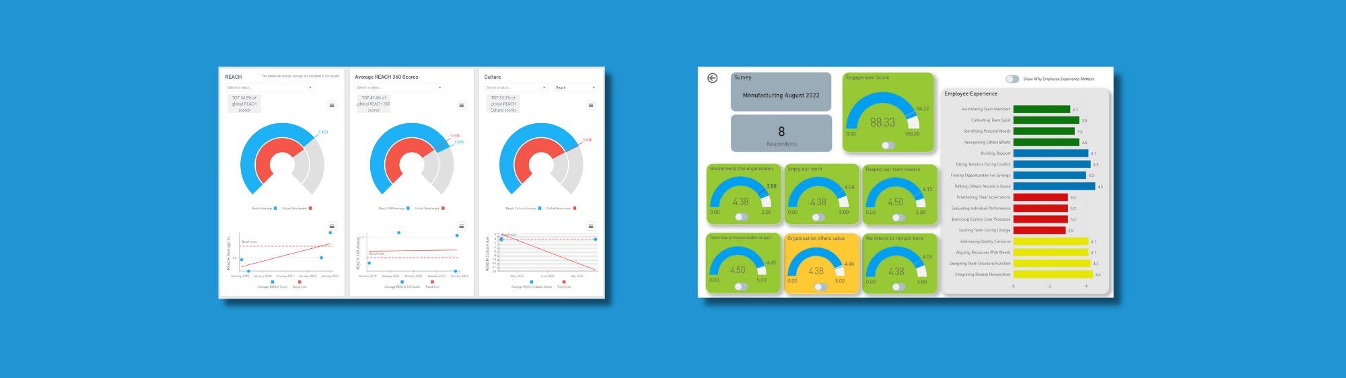
Leaders Can Purposefully Build Teams To Be Productive
With REACH you know what’s working and what needs attention.
Report on growth, benchmarking with AI-enhanced reporting.

- No more teams with too much small talk, not enough action.
- No more chaotic teams with a lack of planning, frequently missing critical details.

The problem: We put teams together by considering the merits of each individual person at a specific point in time. We build project teams, or restructure by considering what we know about people, however, we don’t really know that much about very many people, so we use the limited information we have, and are unavoidably prone to bias.

What happens next? We never have sufficient current information to build a team of people strategically and purposefully. So, we end up putting teams together with the information we have, or just accept how they have formed over time. And very frequently leaders find themselves being constantly frustrated that certain teams just seem to talk talk talk, while other teams seem to rush around, miss important details and make costly errors that lead to rework and poor customer experience.
Currently, we estimate that 0% of our teams seem unbalanced and are likely under-performing as a result.
The Solution: With REACH leaders can purposefully build teams that have the foundations to succeed.
When hiring: Check the Team Visualizer and use the Final Interview Companion.
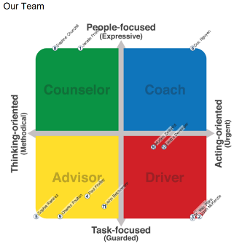
When Building Project Teams or hiring from within: Use the Team Visualizer and Strengths Search.
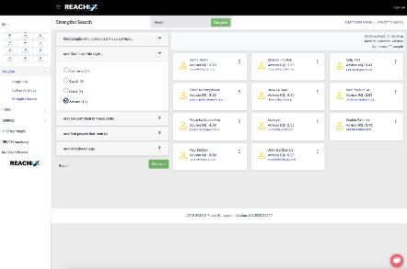
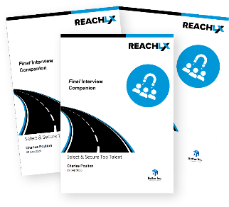
Because great teams don’t happen by accident.

Separation

Surveys: Unlocking Exit Insights
Last year, we lost people that we identify as regrettable loss, the loss of contribution from great people is almost immeasurable, the cost of replacing a person is 2.5X their salary, so the cost has a double amplification of loss of contribution and literal costs of replacement.

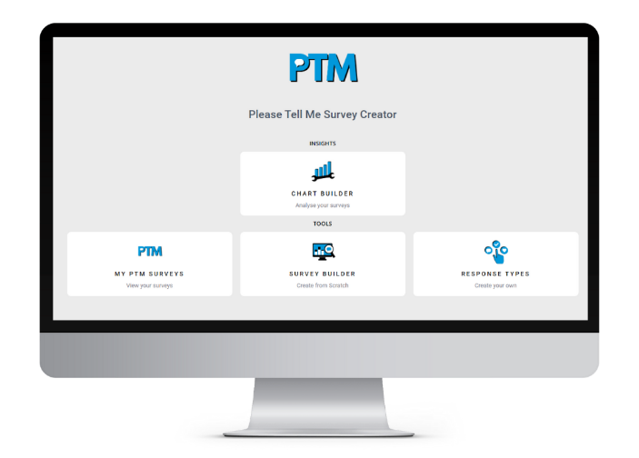
Don’t just watch talent walk away— learn from it.
Separation surveys are your last chance to receive unfiltered feedback, revealing broader issues that might otherwise remain hidden.

AI-Enhanced Understanding: Dive Deeper Than Surface-Level Feedback
Via Separation Surveys, combined with AI-powered sentiment analysis, you’ll gain actionable insights. This data-driven approach empowers you to proactively tackle challenges and keep your top talent onboard.

If you have a talent leak, it’s much more cost-effective to stop the leak than it is to lose your talent, their experience and their knowledge, just to start the recruitment process again.

Everything Forward Cognizant needs to improve culture, leadership and team performance all in one clean, powerful platform.

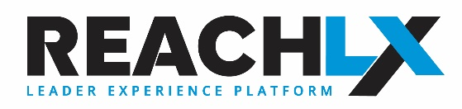

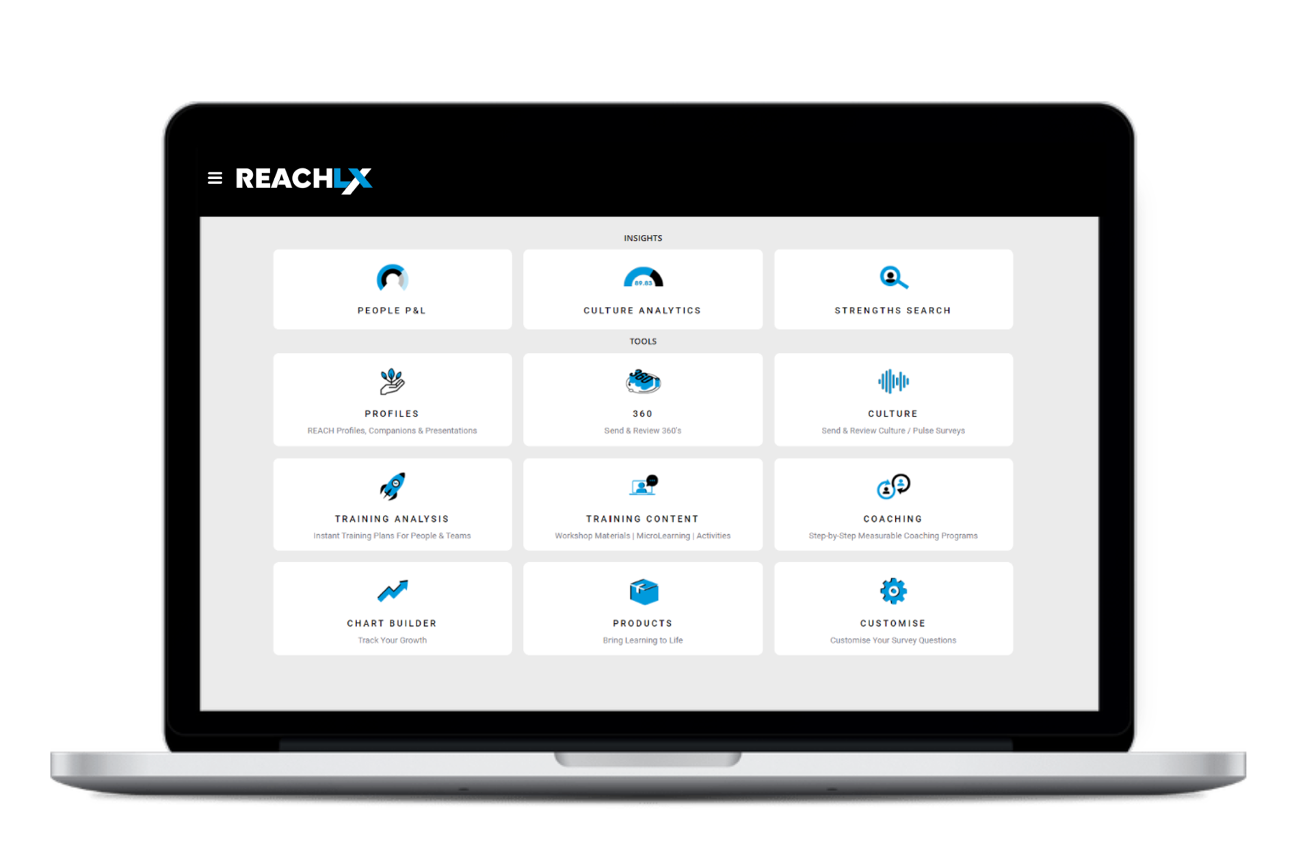

REACH LX is a subscription-based software platform.

Check the subscription plans here. Your REACH Gold Partner will work out the most effective, efficient, and cost-effective roll out with you.

If you don’t already have a Gold Partner, to take the next step, set an appointment time here or phone 1300 92 29 29 and we’ll connect you with the most suitable partner in your area.

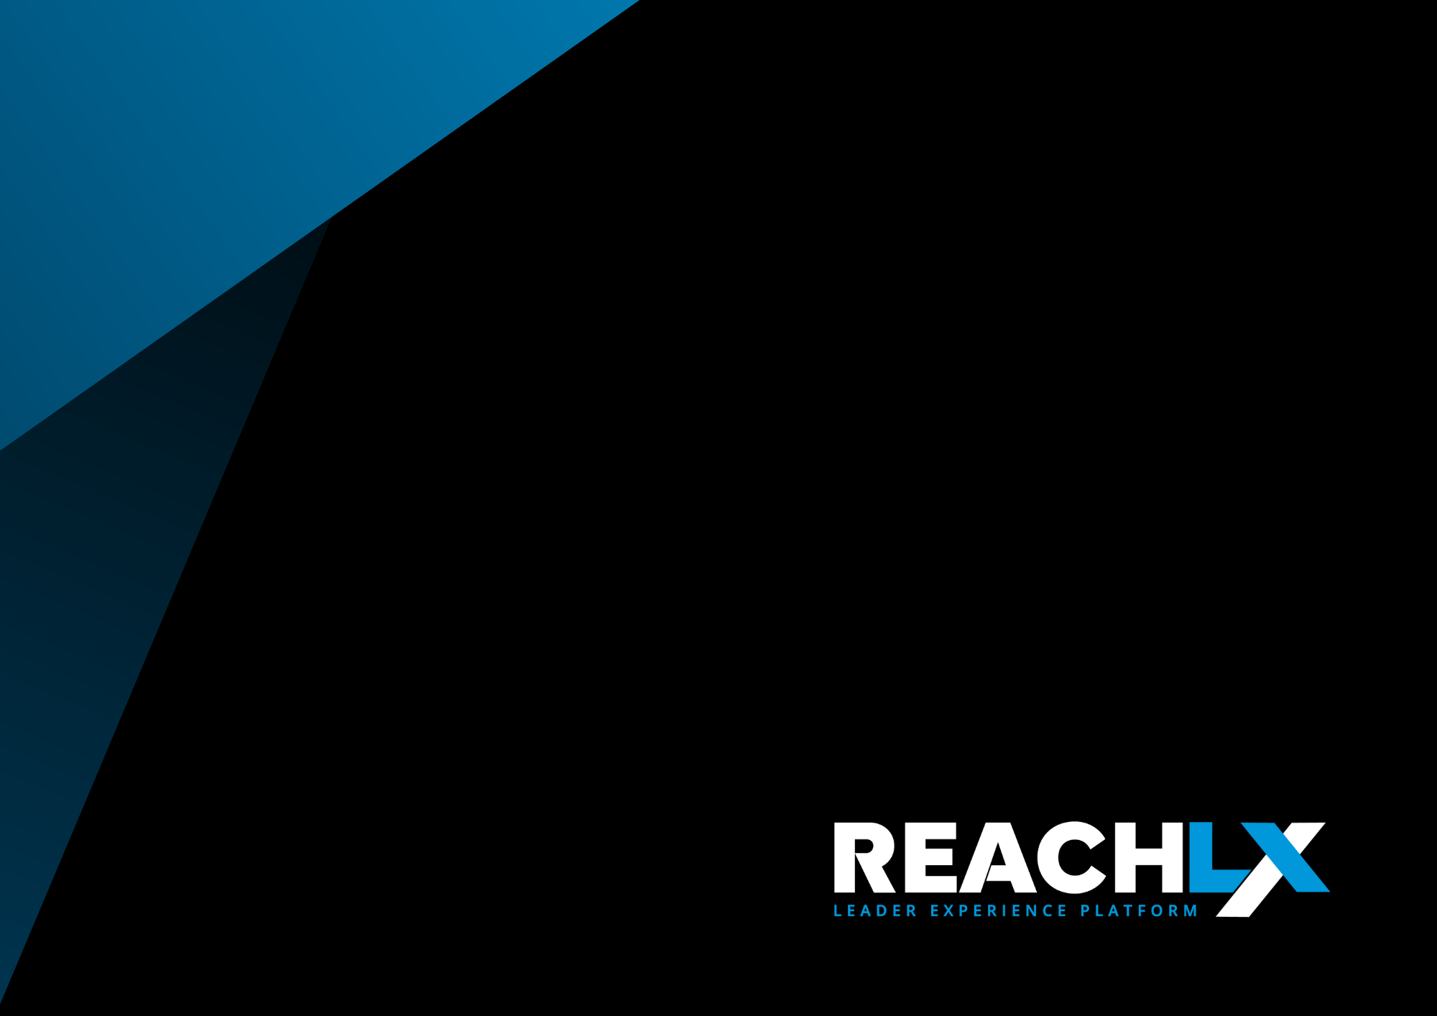

It’s time to equip leaders
at every level to be more effective
at every step of the employee lifecycle.

